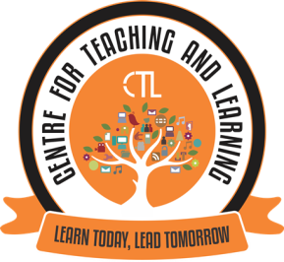
The Centre for Teaching Learning conducted a workshop cum Training programme on ‘G suite’ for Non-teaching staff in two batches on 20th November,2020 and 4th December,2020 with the objective to assist the staff in their daily administrative work.The focus of this workshop was to give elementary exposure on functionalities of Google drive such as Google sheet, Google doc and Google forms. The staff was given hands- on training. This training will help the participants in efficient data collection and document sharing.
The Centre for Teaching Learning (CTL) in collaboration with the International Exchange Programmes of the College, organised the Expert FDP webinar series IV on the topic “Teaching Writing across Disciplines in the Age of Online Education” on 9th December, 2020 for the college teaching faculty.
Prof. Saori Sadoshima, Faculty of International Research and Education, Waseda University, Tokyo was the speaker for this FDP.
This FDP focussed on; various types of online teaching including blended learning, break off and hybrid type of learning which they have been experimenting at Waseda University, Tokyo and also simultaneously highlighted the challenges faced in their implementation. The speaker also gave an insight into Waseda’s academic writing course where she also explained the concept of having Teacher Assistants.The FDP webinar Series IV was attended by around 13 college faculty.

Training programme on ‘G suite’
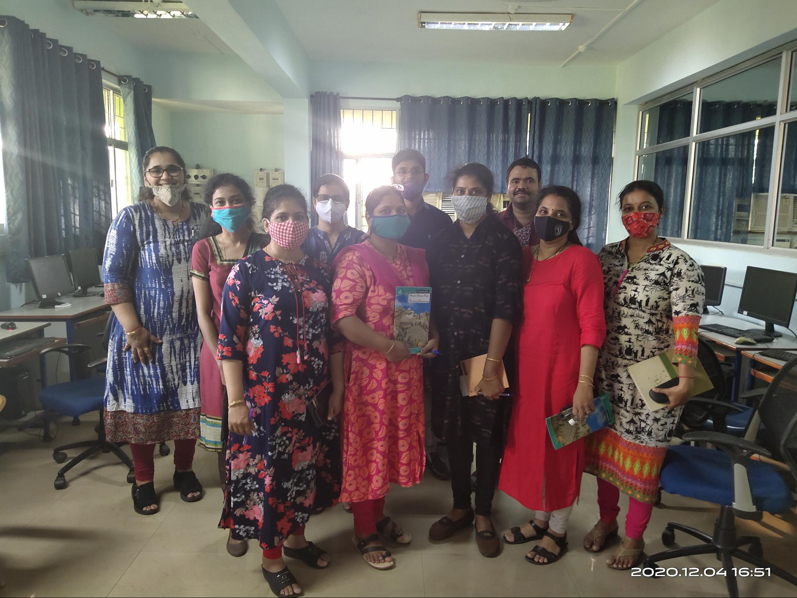
Mrs Rupali Tamuly, CTL member, conducted the training programme on ‘G-suite’ for Non-teaching staff.

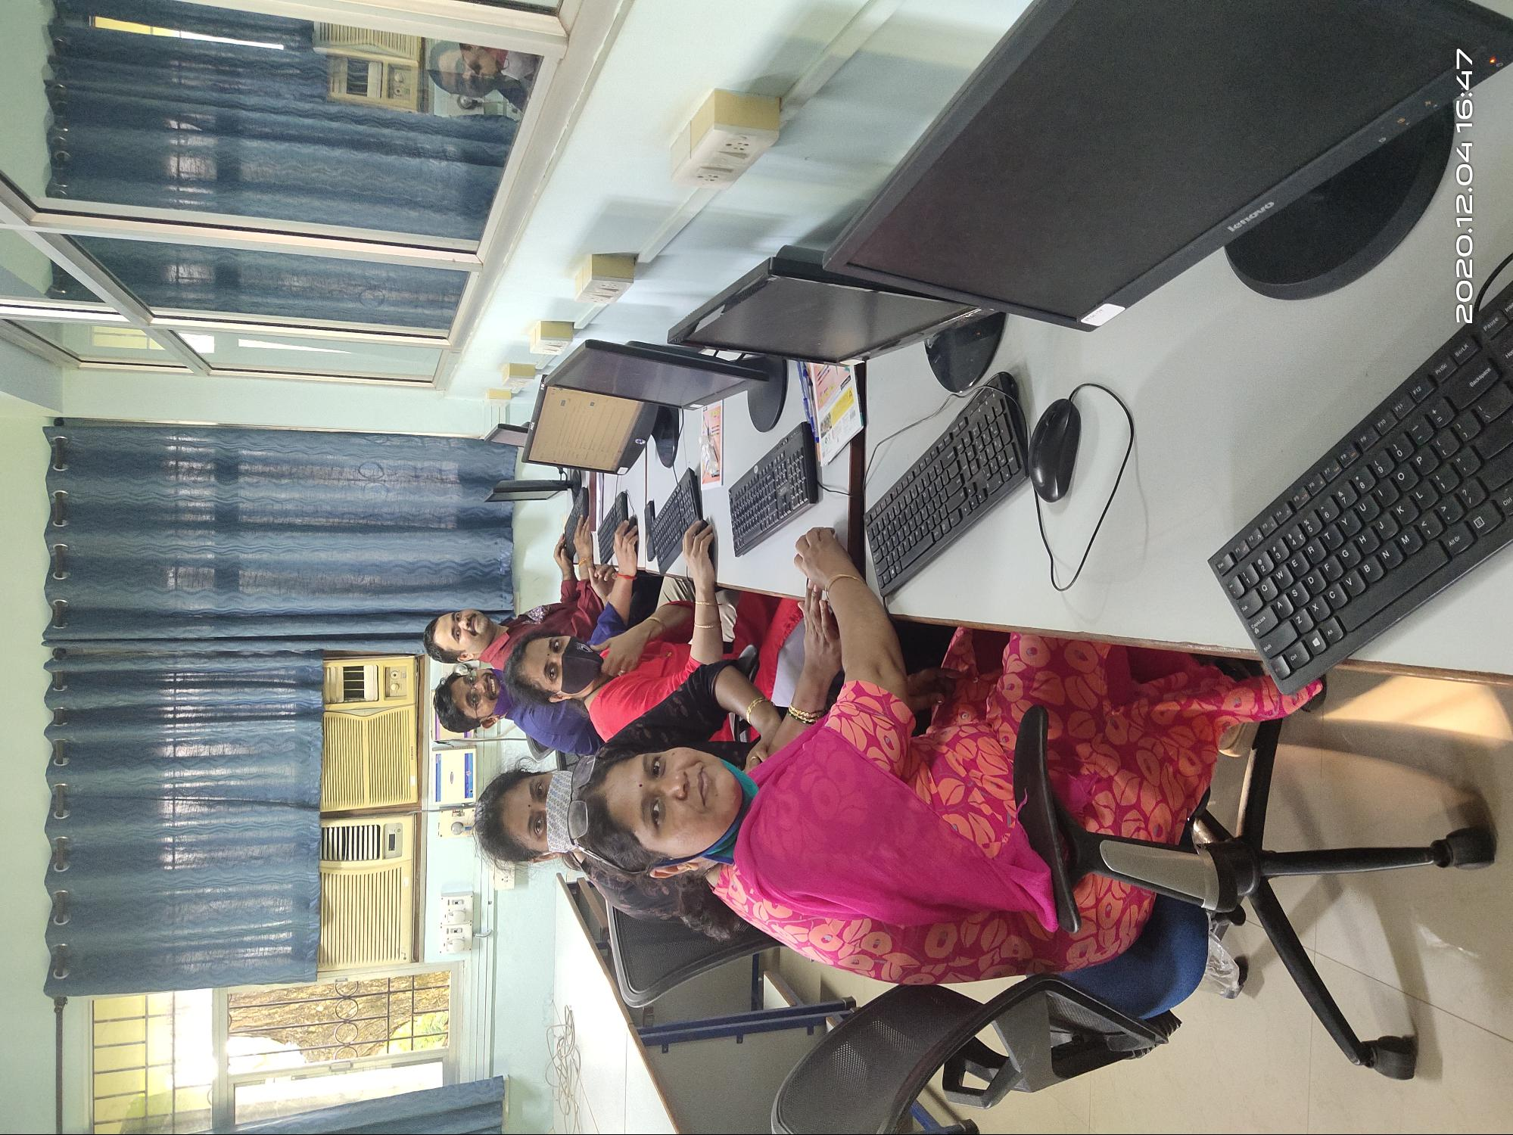
The Non Teaching Staff of the college attending the training session.

Expert FDP webinar series IV :“Teaching Writing across Disciplines in the Age of Online Education”
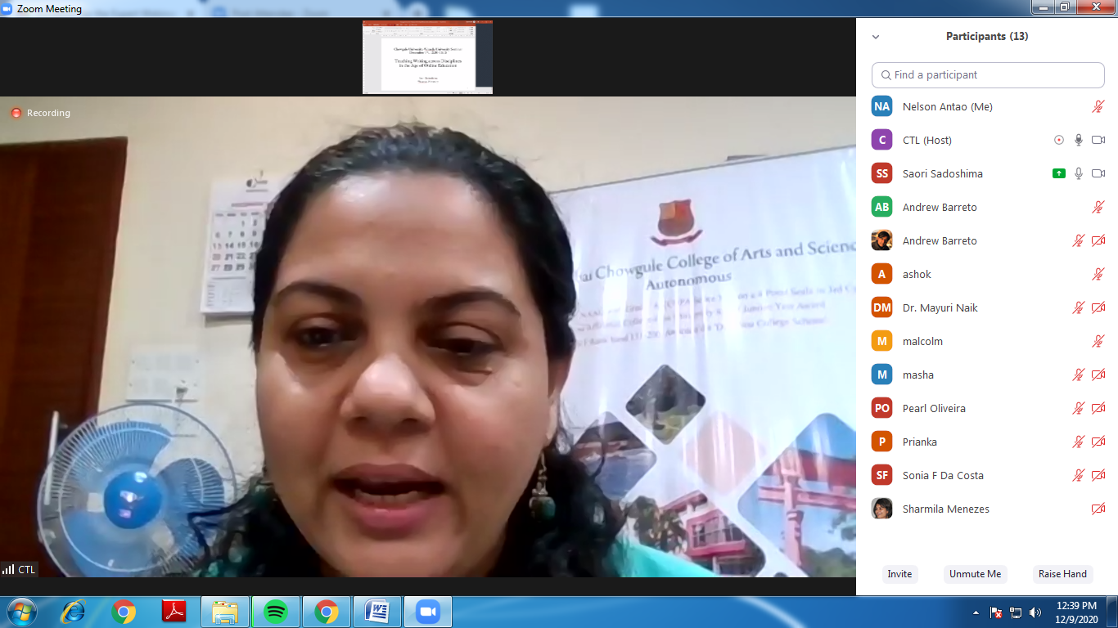
Dr Sameena Fernandes e Falleiro, CTL Director, Introduced the Speaker Prof. Saori Sadoshima and welcomed all the participants for the webinar

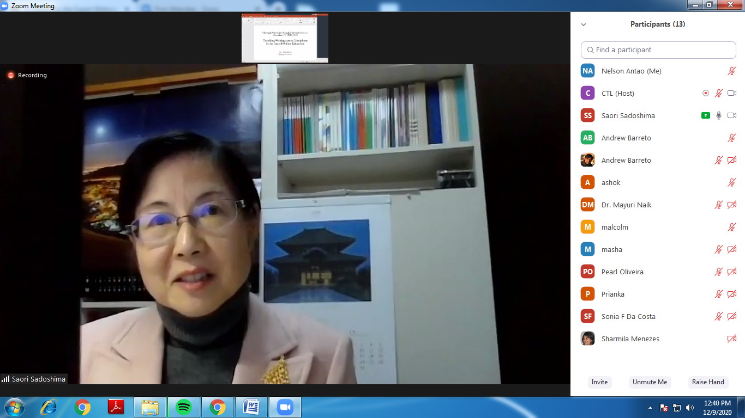
Prof. Saori Sadoshima delivering the session on ‘Teaching Writing Across disciplines in the Age of Online Education’
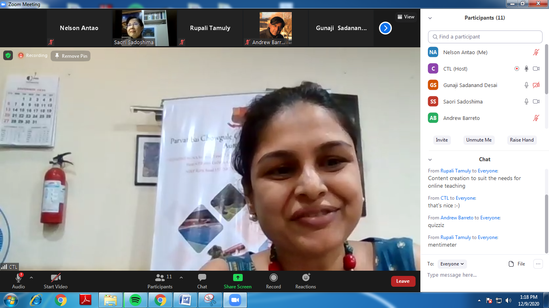
Mrs Sharmila Menezes, Coordinator International Exchange Programmes delivered the vote of thanks to Prof. Saori Sadoshima, Speaker for the webinar for delivering such an enriching session.

